**SMART FARMING – AN IOT ENABLED SMART FARMING APPLICATION**

**TEAMID:PNT2022TMID03145**

**PROJECT REPORT**

1. **INTRODUCTION** 
   1. **Project Overview**

IoT is bringing revolution to almost every aspect of our lives by changing how we do things. The use of Smart IoT devices is on the rise with all the industries heavily investing in IoT. The main aims of investing in IoT are to improve operations efficiency, improve product quality, and reduce the costs of production.

The Agricultural industry is among the industries seeking to reap the benefits of IoT.

**Purpose**

The use of IoT in agriculture is commonly referred to as Smart Farming or Smart Agriculture. It uses various [IoT sensors](https://iotdesignpro.com/articles/top-10-iot-sensors-used-in-iot-applications) to send the farm’s data, like humidity, temperature, soil moisture, etc. to the cloud which can be monitored and controlled from anywhere in the world.

1. **LITERATURE SURVEY**
   1. **Existing problem**

India is agriculture sector, on either side, is losing ground every day, affecting the ecosystem's output capacity. In order to restore vitality and put agriculture back on a path of higher growth, there is a growing need to resolve the issue. A large-scale agricultural system necessitates a great deal of upkeep, knowledge, and oversight. The IoT is a network of interconnected devices that can transmit and receive data over the internet and carry out tasks without human involvement. Agriculture provides a wealth of data analysis parameters, resulting in increased crop yields. The use of IoT devices in smart farming aids in the modernization of information and communication. For better crop growth moisture, mineral, light and other factors can be assumed. This research looks into a few of these characteristics for data analysis with the goal of assisting users in making better agricultural decisions using IoT. The technique is intended to help farmers increase their agricultural output.

1)Accidental deforestation  
2) Soil erosion  
3) High water usage  
4) Energy wastage  
5) Carbon emissions

6) Time consuming process

7) Poor outcomes of cultivation

8) Defense priority not customized to

Prevent intruding animals

* 1. **References**

**1.Zuraida Muhammad, Muhammad Azri Asyraf Mohd Hafez, Nor Adni MatLeh, Zakiah Mohd Yusoff , Shabinar Abd Hamid [1]** The term "Internet of Things" refers to the connection of objects, equipment, vehicles, and other electronic devices to a network for the purpose of data exchange (IoT). The Internet of Things (IoT) is increasingly being utilised to connect objects and collect data. As a result, the Internet of Things' use in agriculture is crucial

**2.Divya J., Divya M.,Janani V. [2]**Agriculture is essential to India's economy and people's survival. The purpose of this project is to create an embedded-based soil monitoring and irrigation system that will reduce manual field monitoring and provide information via a mobile app. The method is intended to help farmers increase their agricultural output. A pH sensor, a temperature sensor, and a humidity sensor are among the tools used to examine the soil. Based on the findings, farmers may plant the best crop for the land

3**.** **H.G.C.R. Laksiri, H.A.C. Dharmagunawardhana, J.V. Wijayakulasooriya** [3]  Development of an effective loT-based smart irrigation system is also a crucial demand for farmers in the field of agriculture. This research develops a low-cost, weather-based smart watering system. To begin, an effective drip irrigation system must be devised that can automatically regulate water flow to plants based on soil moisture levels. Then, to make this water-saving irrigation system even more efficient, an IoT-based communication feature is added, allowing a remote user to monitor soil moisture conditions and manually adjust water flowH.G.C.R. Laksiri, H.A.C. Dharmagunawardhana, J.V. Wijayakulasooriya [3]  Development of an effective loT-based smart irrigation system is also a crucial demand for farmers in the field of agriculture. This research develops a low-cost, weather-based smart watering system. To begin, an effective drip irrigation system must be devised that can automatically regulate water flow to plants based on soil moisture levels. Then, to make this water-saving irrigation system even more efficient, an IoT-based communication feature is added, allowing a remote user to monitor soil moisture conditions and manually adjust water flow

* 1. **Problem Statement Definition**

Mr. Arvind is a farmer with a background in engineering. Together with his father, he has ventured into agriculture. Since he is just starting out in farming, he needs someone to help him through the first few years. He also wants to incorporate technology into farming to cut down on work and labor, increase productivity, produce more, and get ideas for how to improve the soil and plant the next crop. He is actively looking into a few agricultural products that can help him. Many beginning and experienced farmers face these issues

* Who does the problem affect?
* What are the boundaries of the problem?
* What is the issue?
* When does the issue occur?
* Why is it important that we fix the problem?
* What solution to solve this issue?

1. **IDEATION & PROPOSED SOLUTION**
   1. **Empathy Map Canvas**

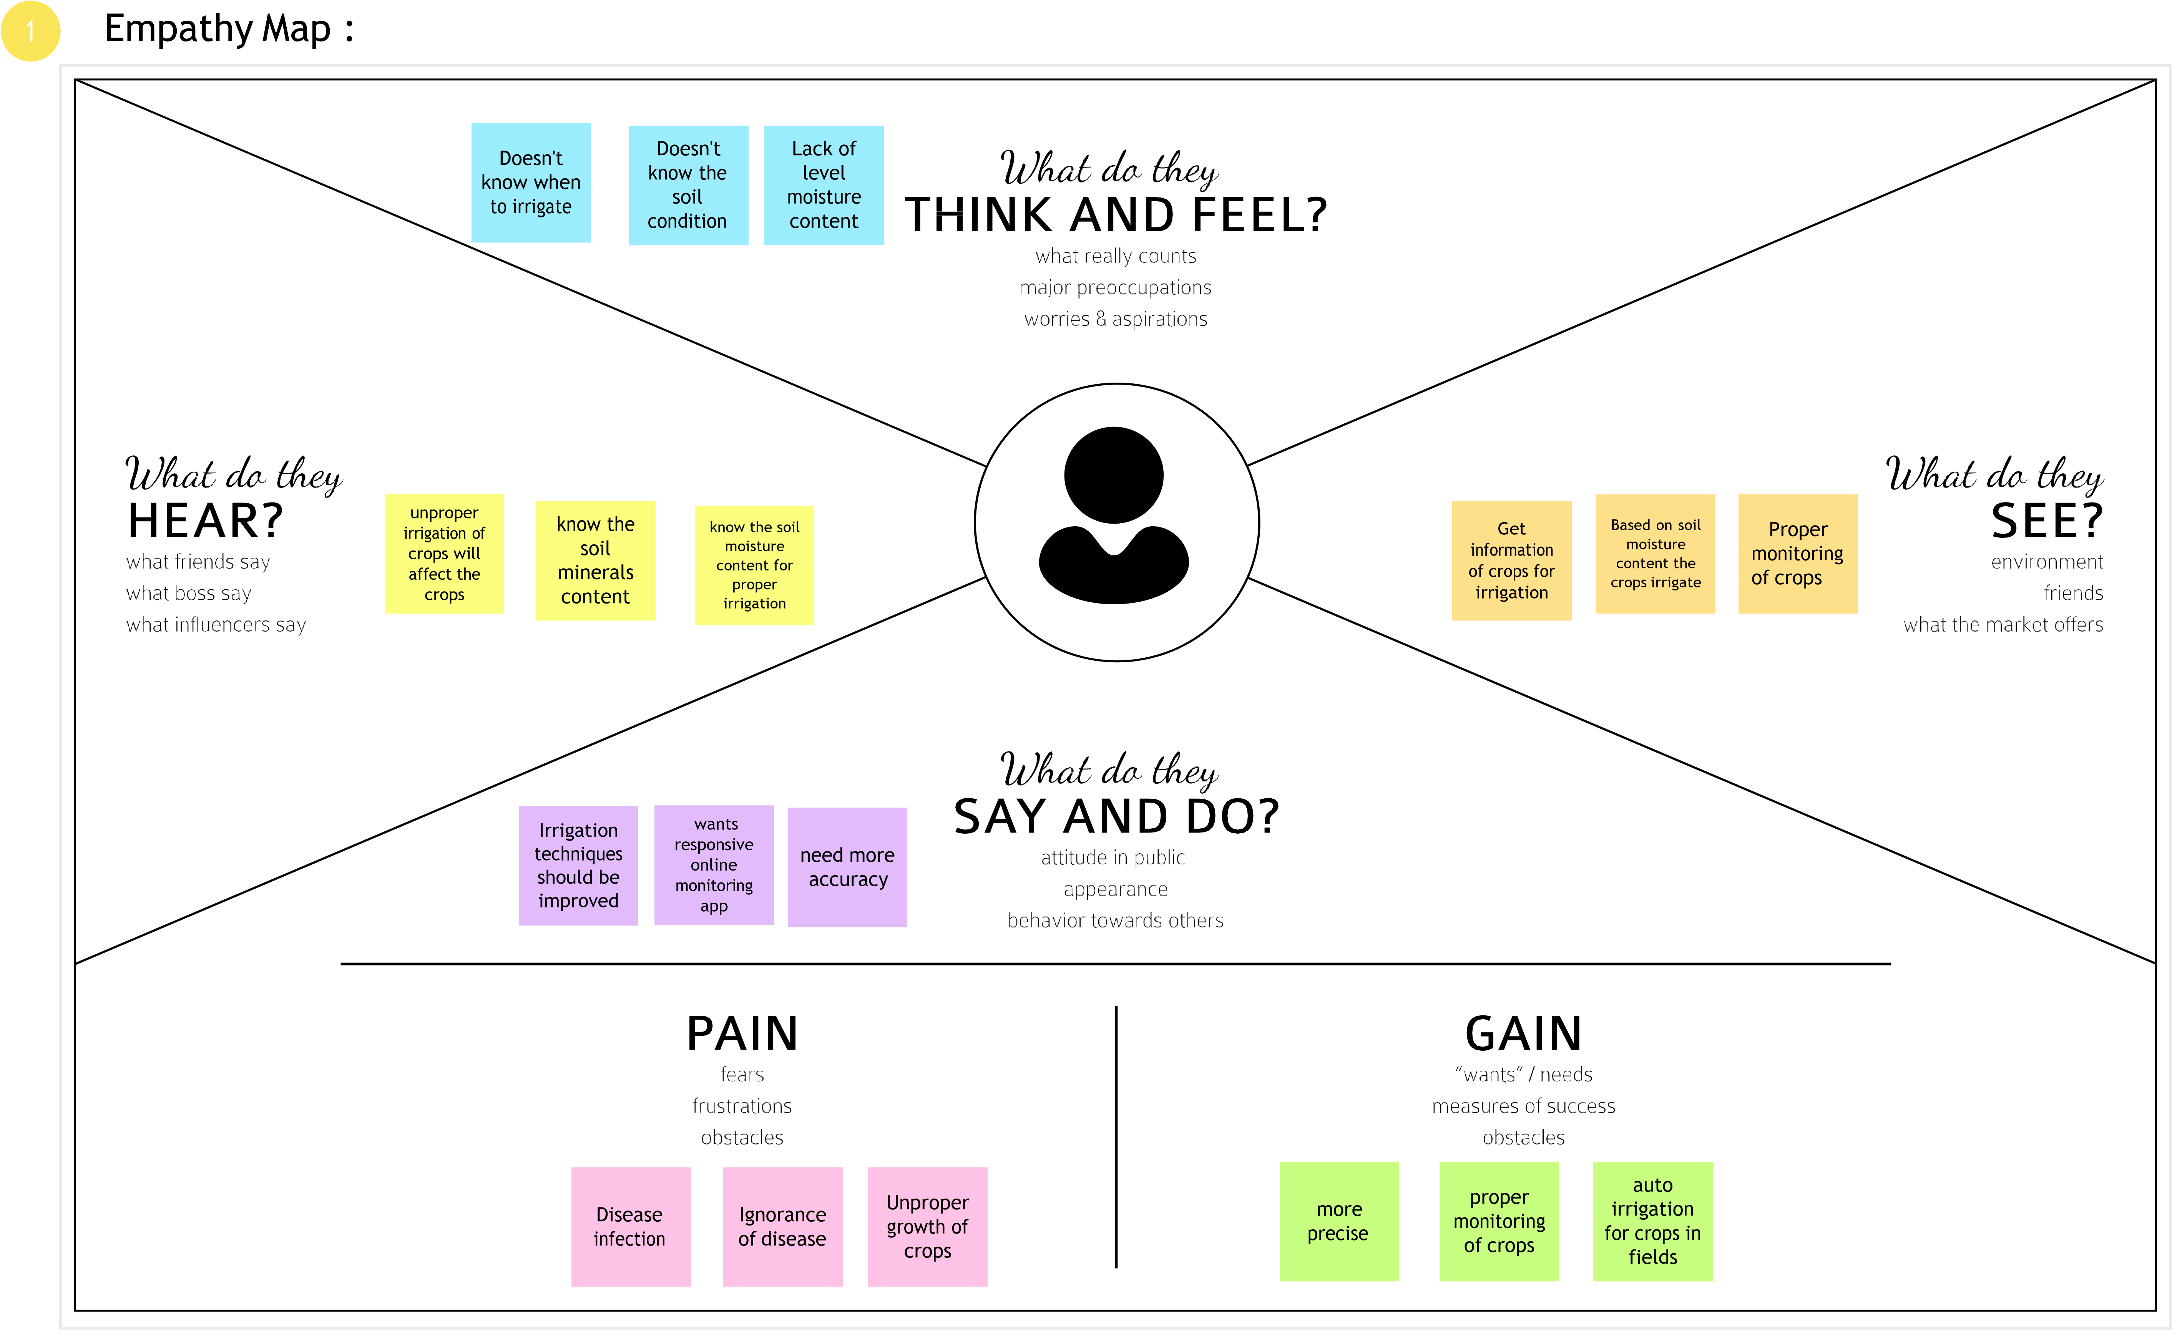

* 1. **Ideation & Brainstorming**

Ideation is the process where you generate ideas and solutions through sessions such as Sketching, Prototyping, Brainstorming, Brainwriting, Worst Possible Idea, and a wealth of other ideation techniques.

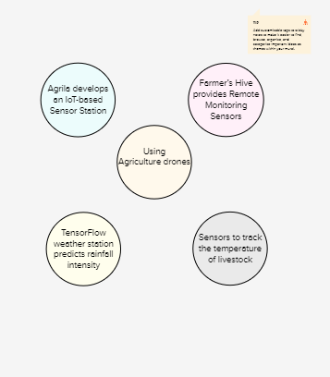

* 1. **Proposed Solution**
  2. Problem Statement

Watering the field is a difficult process, Farmers have to wait in the field until the water covers the whole farm field. Power Supply is also one of the problems. In Village Side, the power supply may vary. The Biggest Challenges Faced by IoT in the Agricultural Sector are Lack of Information, High Adoption, Cost and Security Concerns, etc

Idea / Solution description

As is the case of precision Agriculture Smart Farming Technique Enables Farmers better to monitor the fields and maintain the humidity level accordingly. The Data collected by sensors, In terms of humidity, temperature, moisture, and dew detections help in the weather pattern in Farms. So cultivation is done for suitable crops.

Novelty

It helps the farmer to operate the motor from anywhere.

* 1. **Problem Solution fit**





1. **REQUIREMENT ANALYSIS**

## Functional Requirements:

Following are the functional requirements of the proposed solution.

|  |  |  |
| --- | --- | --- |
| **FR No.** | **Functional Requirement (Epic)** | **Sub Requirement (Story / Sub-Task)** |
| FR-1 | User Registration | EMAIL:  Enter email address PASSWORD:  Enter password |
| FR-2 | User Confirmation | Confirmation via Email. Thanks for your email. |
| FR-3 | Log in to system | Serve authenticated content |
| FR-4 | Manage Modules | Manage System Admins Manage Roles of User Manage User permission |
| FR-5 | Check whether condition | Temperature monitoring status  Humidity monitoring  Status |
| FR-6 | Log out | Exit |

## Non-functional Requirements:

Following are the non-functional requirements of the proposed solution.

|  |  |  |
| --- | --- | --- |
| **FR**  **No.** | **Non-Functional Requirement** | **Description** |
| NFR- 1 | **Usability** | Usability includes easy understanding and learn ability, efficiency in use,remember ability, lack of errors in operation and subjective pleasure. |
| NFR- 2 | **Security** | Sensitive and private data must be protected from their production until the decision-making and storage stages. |
| NFR- 3 | **Reliability** | The shared protection achieves a better trade-off between costs and reliability.  The model uses dedicated and shared protection schemes to avoid farm service outages. |

|  |  |  |
| --- | --- | --- |
| NFR-4 | **Performance** | The idea of implementing integrated sensors with sensing soil and environmental parametersin farming will be more efficient. |
| NFR-5 | **Availability** | Automatic adjustment of farming equipment made possible by linking information like crops/weather and equipment to auto-adjust temperature,  humidity, etc. |
| NFR-6 | **Scalability** | Scalability is a major concern for IoT platforms. It has shown that different architectural choices of IoT platforms affect system scalability,real time decision- making is feasible in an environment composed of dozens of thousand. |

1. **PROJECT DESIGN**
   1. **Data Flow Diagrams**

A Data Flow Diagram (DFD) is a traditional visual representation of the information flows within a system. A neat and clear DFD can depict the right amount of the system requirement graphically. It shows how data enters and leaves the system, what changes the information, and where data is stored.

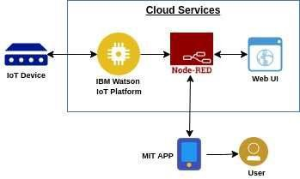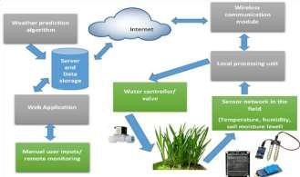

* The different soil parameters temperature, soil moistures and then humidity are sensed using different sensors and obtained value is stored in the IBM cloud.
* Arduino UNO is used as a processing Unit that process the data obtained from the sensors and whether data from the weather API.
* NODE-RED is used as a programming tool to write the hardware, software, and APIs. The MQTT protocol is followed for the communication.
* All the collected data are provided to the user through a mobile application that was developed using the MIT app inventor.
* The user could plan through an app, weather to water the crop or not depending upon the sensor values. By using the app, they can remotely operate to the motor switch.
  1. **Solution & Technical Architecture:**

**Solution Architecture:**

Solution architecture is a complex process – with many sub-processes – that bridges the gap between business problems and technology solutions. Its goals are to:

* Find the best tech solution to solve existing business problems.
* Describe the structure, characteristics, behavior, and other aspects of the software to project stakeholders.
* Define features, development phases, and solution requirements.
* Provide specifications according to which the solution is defined, managed, and delivered.

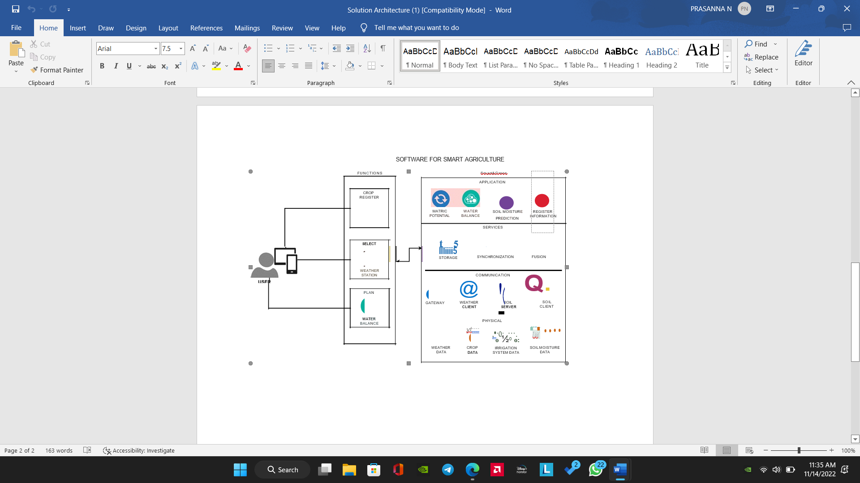

* 1. **User Stories**

|  |  |  |  |  |  |  |
| --- | --- | --- | --- | --- | --- | --- |
| **User Type** | **Functional Requirement** | **User Story Number** | **User Story/Task** | **Acceptance criteria** | **Priority** | **Release** |
| Customer (Mobile user) | Registration | USN-1 | As a user, I can register for the application by entering my  email, password and confirming my password. | I can access my account/ dashboard | High | Sprint-1 |
|  | Permission | USN-2 | As a user, I will receive confirmation email once I have registered for the application. | I can receive confirmation email & click  confirm. | High | Sprint-1 |
| Customer (Web user) | Login | USN-3 | As a user, I can log into the application by entering email & password. | I can register & access  the dashboard with Login | High | Sprint-2 |
|  | Check credentials | USN-4 | As a user, I can register for the application through mobile application | Temperature and  Humidity details | Medium | Sprint-1 |
|  | Dashboard | USN-5 | As a user can view the dashboard and this dashboard include the check roles of access and then move to the manage modules. | I can view the dashboard in this smart farming application system. | Medium | Sprint-1 |
| Customer care Executive | MIT app | USN-6 | To make the user to interact with the software. | Database to store in cloud services. | High | Sprint-1 |
| Administrator | IOT devices | USN-7 | As a user once view the manage modules this describes the manage system admins and Manage Roles of user and etc.., |  | Medium | Sprint-1 |
|  | Log out | USN-8 | Exit | Sign out | High | Sprint-1 |

**5.PROJECT PLANNING & SCHEDULING**

5.1 Sprint Planning & Estimation

**Product Backlog, Sprint Schedule, and Estimation**

|  |  |  |  |  |  |  |
| --- | --- | --- | --- | --- | --- | --- |
| **Sprint** | **Functional Requirement (Epic)** | **User Story Number** | **User Story /Task** | **Story Points** | **Priority** | **Team Member** |
| **Sprint-1** | Registration (Farmer Mobile User) | UNS-1 | As a user, I can register for the application by entering my email, password, and confirming my  password. | 2 | High | PRATEEK RAM RA  (Leader) |
| **Sprint-1** | Login | UNS-2 | As a user, I will receive confirmation email once I have registered  for the application | 1 | High | PRASANNA N  (Member 1) |

|  |  |  |  |  |  |  |
| --- | --- | --- | --- | --- | --- | --- |
| **Sprint-2** | User Interface | UNS-3 | As a user, I can register for the application through Facebook | 3 | Low | PREMKUMAR  (Member 2) |
| **Sprint-1** | Data Visualization | UNS-4 | As a user, I can register  for the application through GMAIL | 2 | Medium | PRAVIN KUMAR P  (Member 3) |
| **Sprint-3** | Registration (Farmer -Web User) | USN - 1 | As a user, I can log into the application by entering email and  password | 3 | High | PRATEEK RAM RA  (Leader) |
| **Sprint - 2** | Login | USN - 2 | As a registered user, I need to easily login log into my registered account via the web page in minimum time | 3 | High | PRASANNA N  (Member 1) |
| **Sprint - 4** | Web UI | USN - 3 | As a user, I need to have a friendly user interface to easily view and access the resources | 3 | Medium | PREM KUMAR B  (Member 2) |
| **Sprint - 1** | Registration (Chemical Manufacturer - Web user) | USN - 1 | As a new user, I want to first register using my organization email and create a password for  the account. | 2 | High | PRAVIN KUMAR P  (Member 3) |

|  |  |  |  |  |  |  |
| --- | --- | --- | --- | --- | --- | --- |
| **Sprint - 4** | Login | USN - 2 | As a registered user, I need to easily log in using the registered account via the web  page. | 3 | High | PRATEEK RAM RA  (Leader) |
| **Sprint - 3** | Web UI | USN - 3 | As a user, I need to have a user friendly interface to easily view and access the resources. | 3 | Medium | PRASANNA N  (Member 1) |
| **Sprint - 1** | Registration (Chemical Manufacturer -  Mobile User) | USN - 1 | As a user, I want to first register using my email and create a password  for the account. | 1 | High | PREM KUMAR B  (Member 2) |
| **Sprint - 1** | Login | USN - 2 | As a registered user, I  need to easily log in to the application. | 2 | Low | PRAVIN KUMAR P  (Member 3) |

**Project Tracker, Velocity & Burndown Chart:**

|  |  |  |  |  |  |  |
| --- | --- | --- | --- | --- | --- | --- |
| **Sprint** | **Total Story**  **Points** | **Durati on** | **Sprint Start**  **Date** | **Sprint End Date**  **(Planned)** | **Story Points Completed (ason Planned End Date)** | **Sprint Release Date (Actual)** |
| Sprint-1 | 12 | 6 Days | 24 Oct 2022 | 29 Oct 2022 | 20 | 29 Oct 2022 |
| Sprint-2 | 6 | 6 Days | 31 Oct 2022 | 05 Nov 2022 | 20 | 30 OCT 2022 |
| Sprint-3 | 6 | 6 Days | 07 Nov 2022 | 12 Nov 2022 | 20 | 6 NOV 2022 |
| Sprint-4 | 6 | 6 Days | 14 Nov 2022 | 19 Nov 2022 | 20 | 7 NOV 2022 |

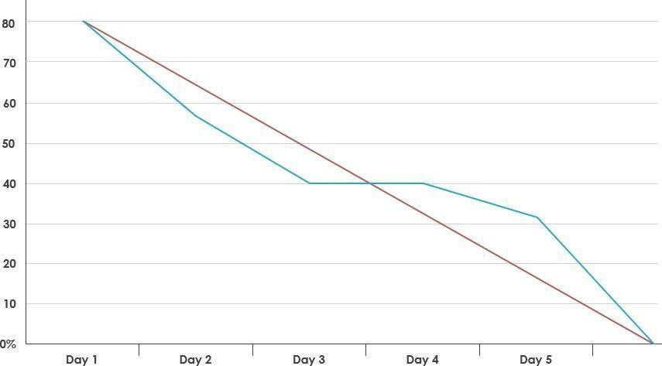**Burndown Chart**

1. **CODING & SOLUTIONING (Explain the features added in the project along with code)**
   1. Feature 1
   2. Feature 2
   3. Database Schema (if Applicable)
2. **TESTING** 
   1. Test Cases
   2. User Acceptance Testing
3. **RESULTS**
   1. Performance Metrics
4. **ADVANTAGES & DISADVANTAGES**
5. **CONCLUSION**
6. **FUTURE SCOPE**
7. **APPENDIX**

Source Code

GitHub & Project Demo Link